CORPORATE RECRUITMENT SYSTEN

***FIRST INCREMENT***



3/10/2014

PREETHI REDDY PESARU & DEEPTHI JONNALAGADDA

**FIRST INCREMENT REPORT**

* The screen shot of the first home page of our Coorporate Recruting System looks like below

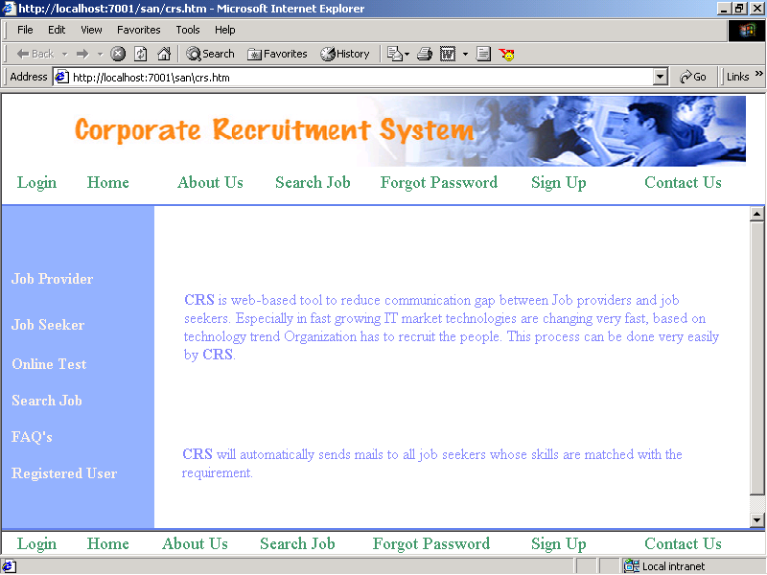

This is the login page for the job seeker

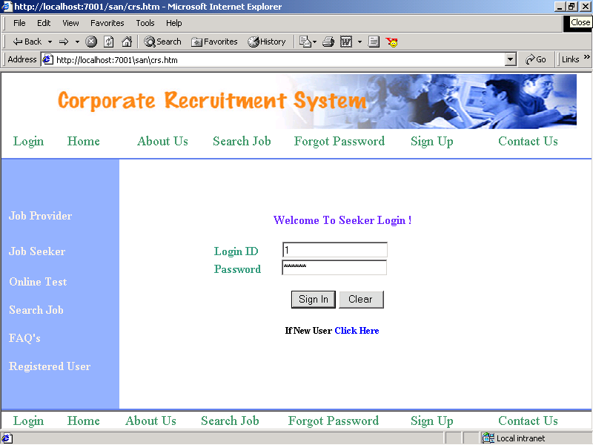

**User Stories Using ScrumDo**

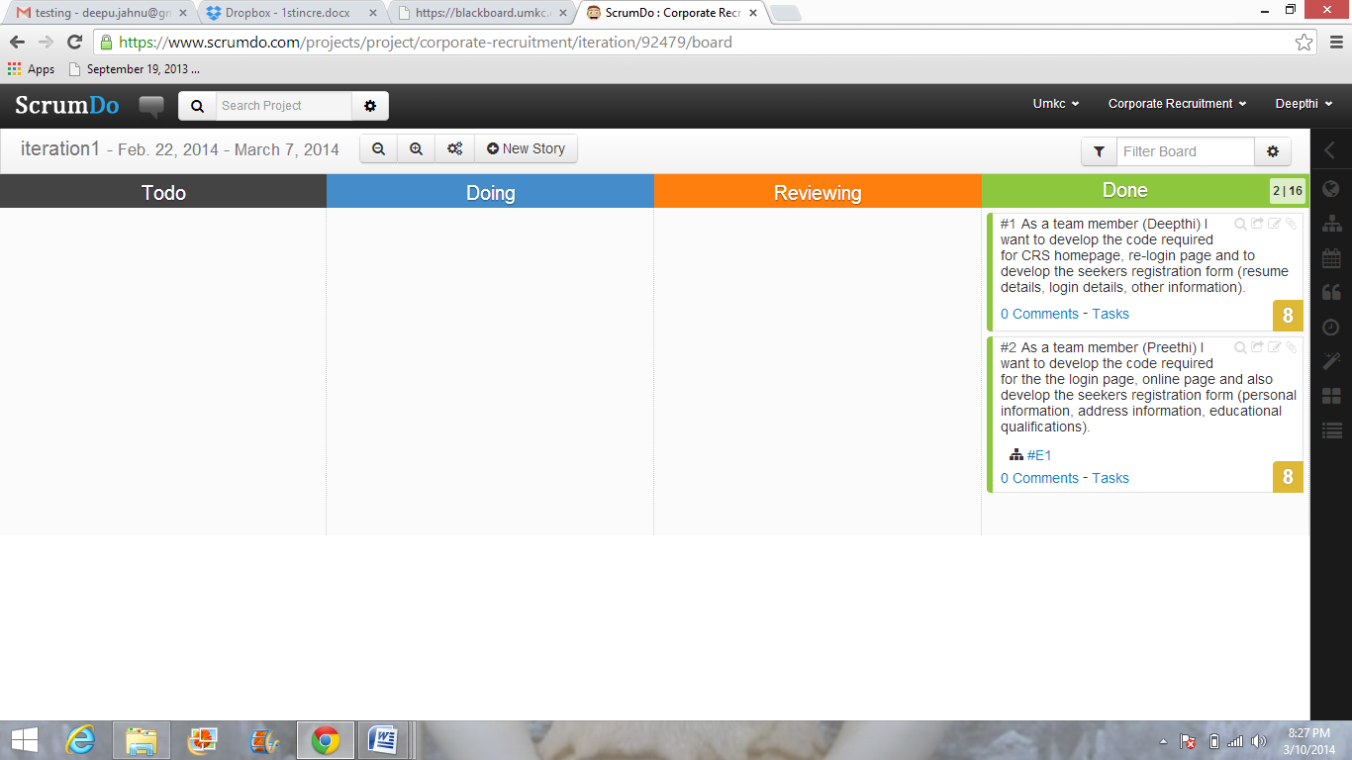

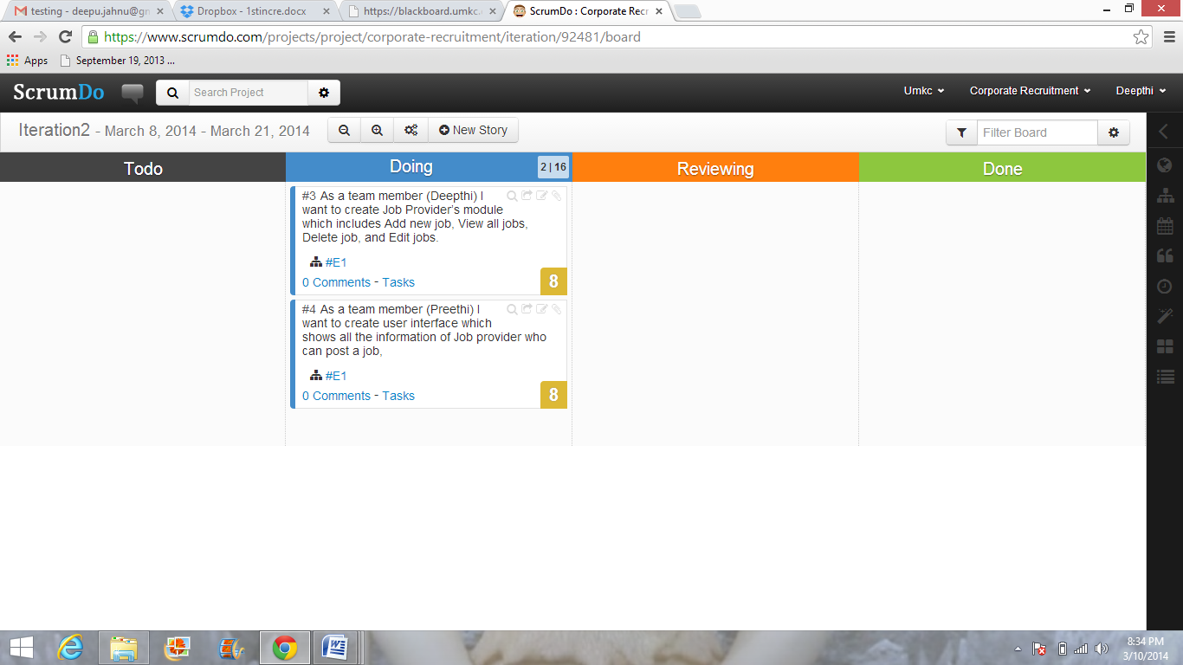

**Detail Design of Services**

**Class diagram**:

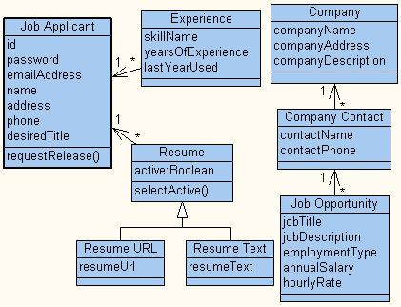

**Data flow diagram**:

Job Provider

Job Seeker

Online Test

Login

Display the Screen based on the login

Process logic:

Provider

No

Yes

Yes

New User

Option to Create New User

Login Form for User Validation

Message with Re-login Form

If Job Provider Or

Job Seeker

Job Provider Specific Page with all Options

Job Seeker Specific Page with All Options

No

Design of Mobile Client Interface

Features:

Sign in button, clear button, post button, update button, send button

Styles:

Cascading Style Sheet

Technologies:

We are using

* HTML
* JavaScript
* JSP
* SQL

In the first increment we have designed the login page, job-seekers login page, online login page and also a re-login page. If suppose user enters the wrong details they will be redirected to a re-login page. We have also designed the job-seekers registration form which is very important for a job-seeker to register his details in the Corporate Recruitment System. This will be easy for a job provider to reach the job seeker in an efficient way.

Corporate Recruitment System is a web-based application. When we talk about hardware and software, we have to mention requirements on both the Client and Server part.

* + - Internet connection with 33.6 KBPS Modem.
    - Pentium 2.77 GHz. 40 GB HDD, 512 MB RAM (Server).
    - Any P.C with Windows compatibility, 64 MB RAM (Client).
    - J2SDK 1.4 Enterprise Edition
    - Tomcat 5.0 version
    - Java Server Pages
    - JDBC/ODBC drivers installed.
    - Functional Java enabled browser.
    - Data Base (Oracle 8i).
    - Operating System (Windows).

|  |  |
| --- | --- |
|  |  |
|  |  |
|  |  |

**IMPLEMENTATION**

**Screen shots: JSFiddle**

1. This is how the login page of CRS looks like

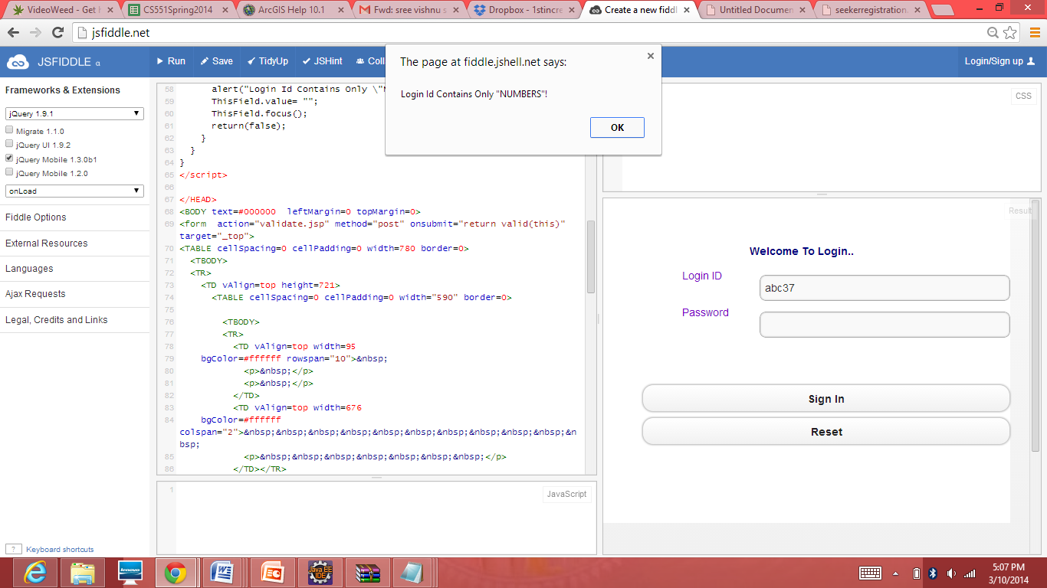

1. We can enter only numbers in the login id and you get a login id only after registering in the CRS

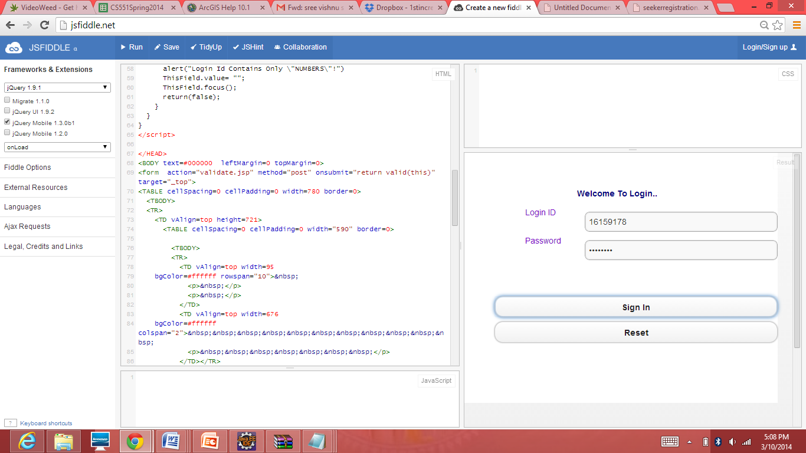

1. This is the screen shot of Online Login Page.

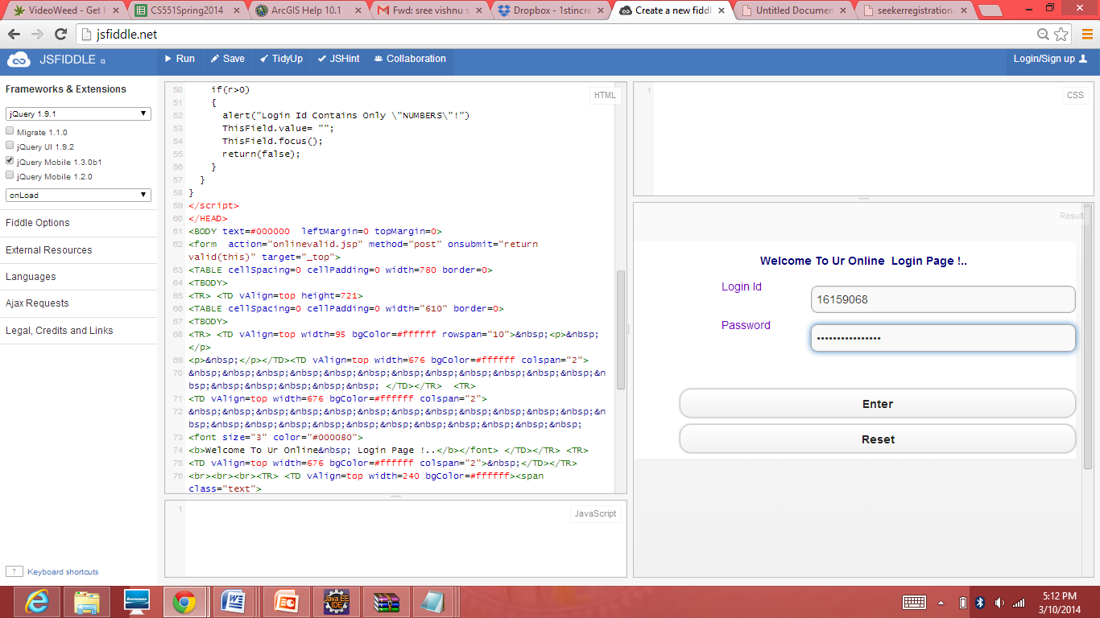

1. Job seekers login page:

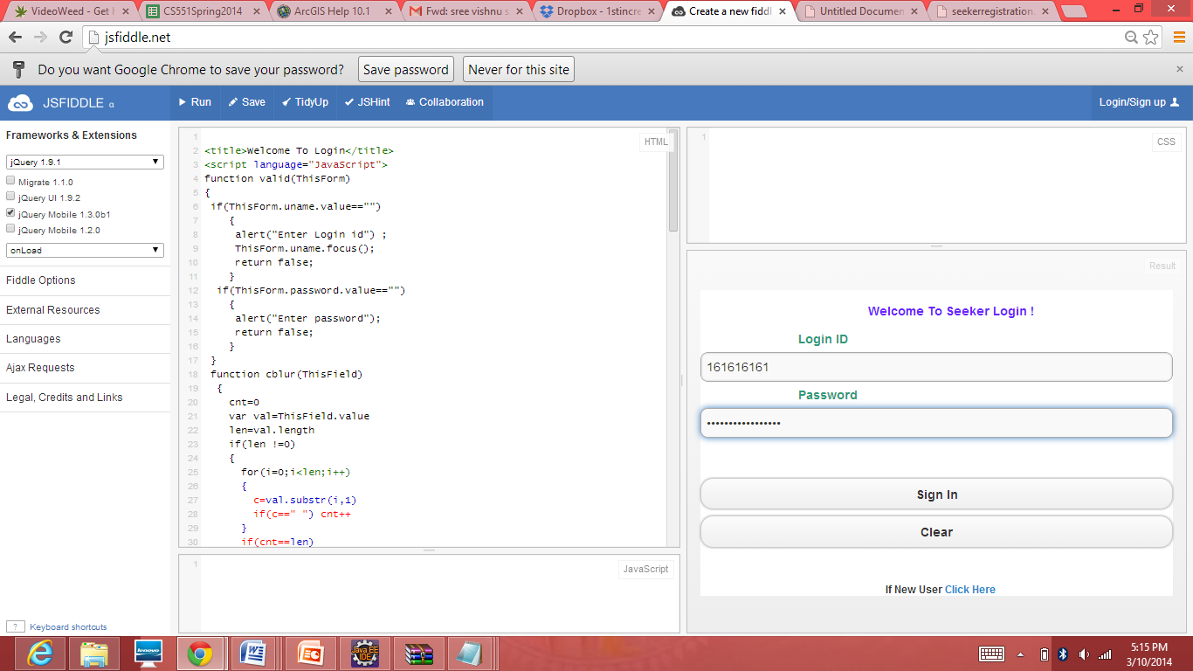

5. This is the Personal information part of the Job seeker registration form.

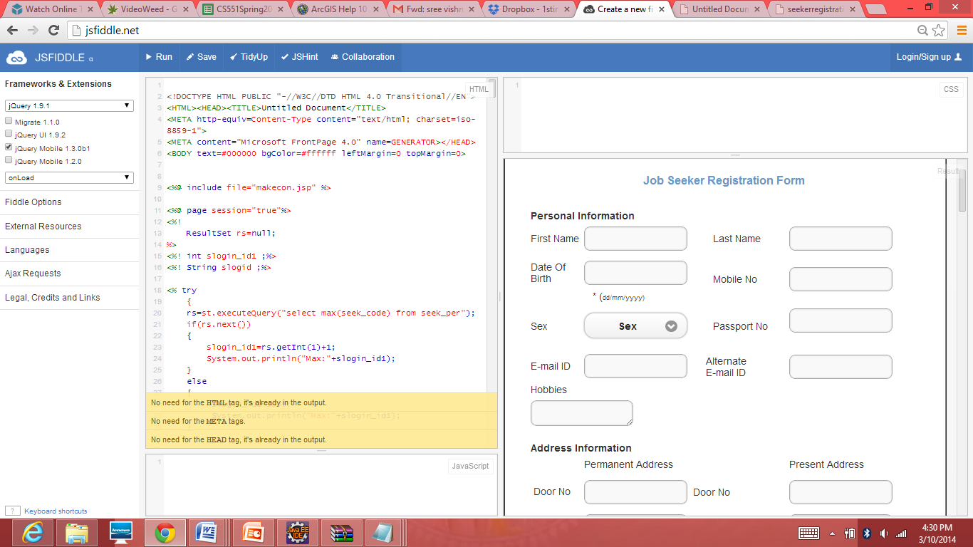

6. This is the Address information and Resume Details part of the Job seeker registration form

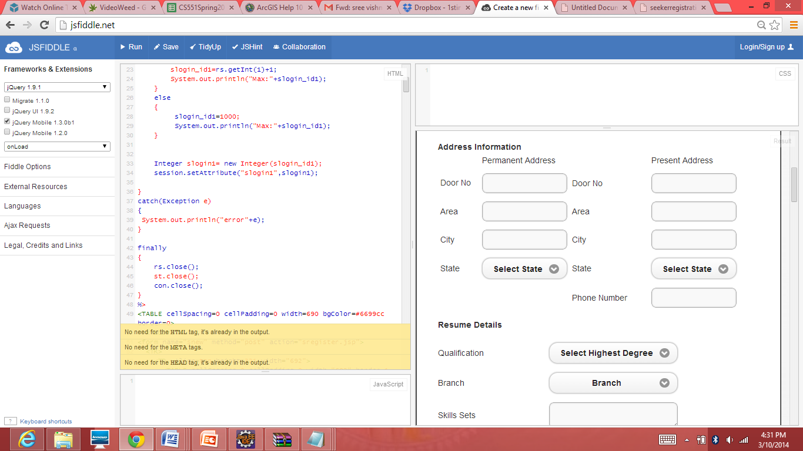

7. This is the screen shot of the Educational information part of the Job seeker registration form.

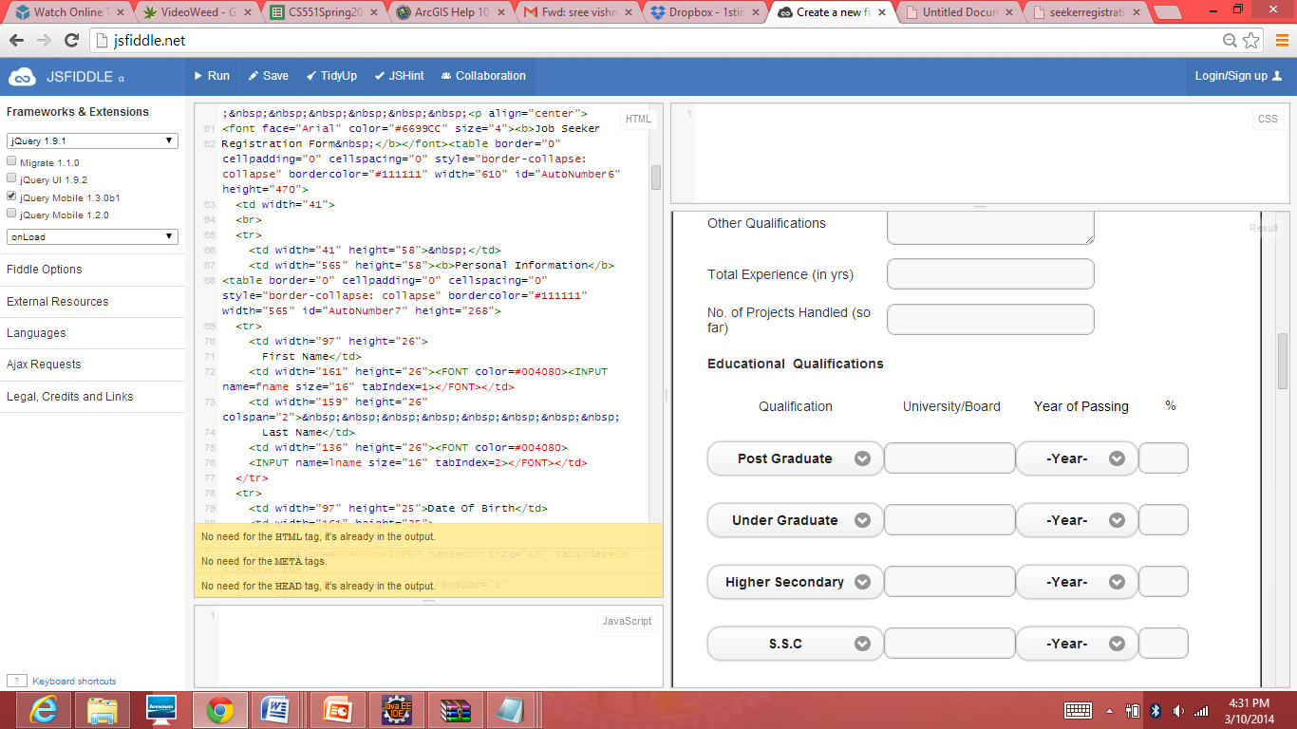

8. This is the screen shot of login details of the Job seeker registration form.

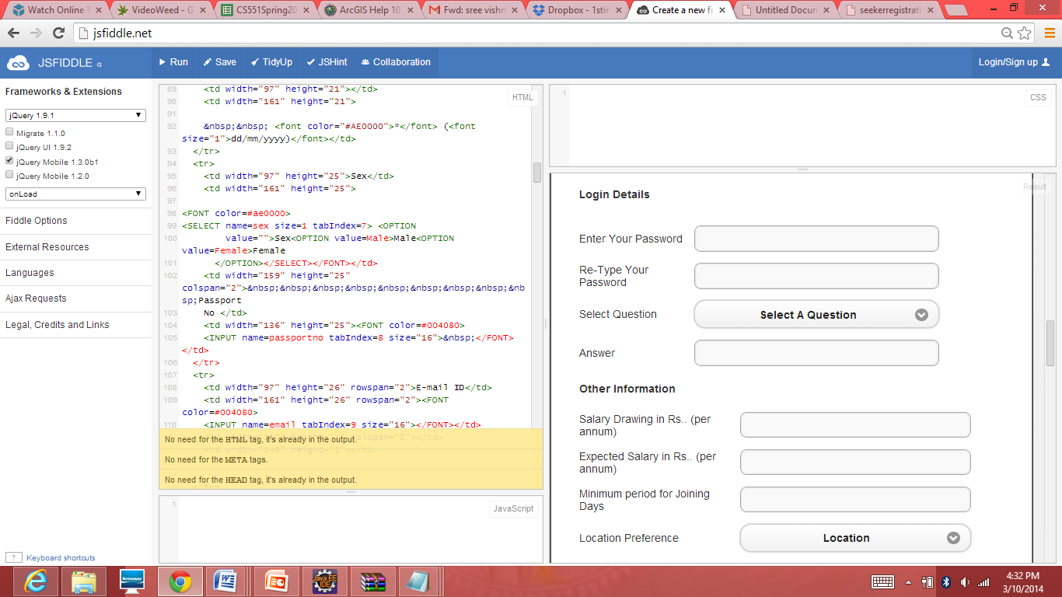

9. Once the job seeker is done with filling all this information in the registration form he can click submit so that all his information will be available for the job providers .

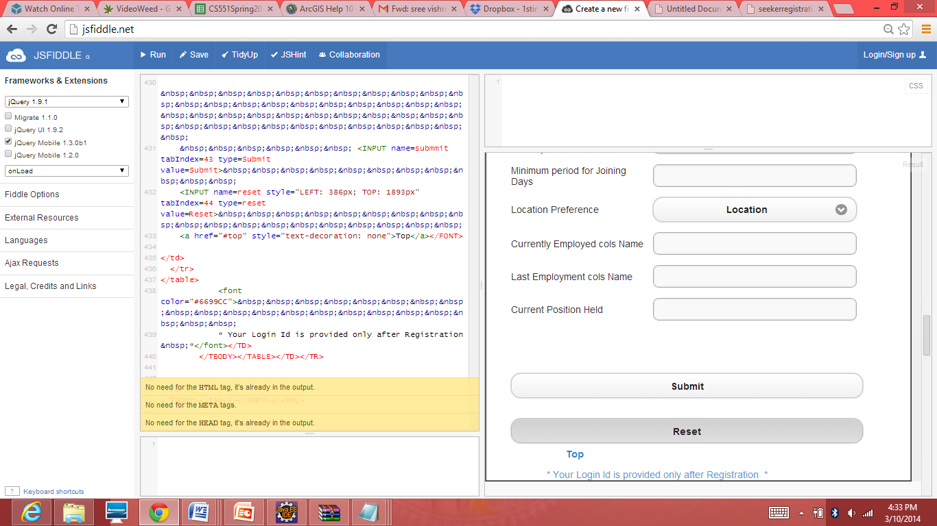

10. This is how a re-login page looks like. User is redirected to this page when he/she enters the wrong details.

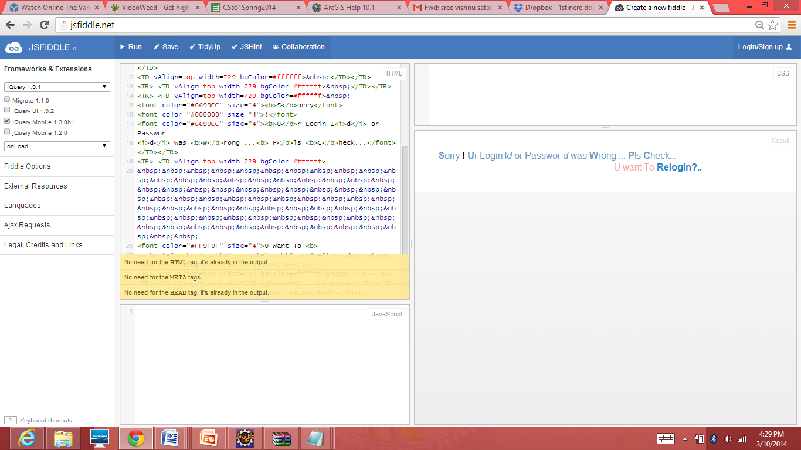

**TESTING:**

Once code has been generated, program testing process focuses on the logical internals of the software, assuring that all statements have been tested, and on the functional externals that is, conducting tests to uncover errors and ensure that defined input will produce actual results that agree with required results.

TESTING OBJECTIVES:

1. Testing is process of executing a program with the intent of finding an error.
2. A good test case design is one that has a probability of finding an as yet undiscovered error.
3. A successful test is one that uncovers an as yet undiscovered error.

**Unit Testing:**

Unit testing focuses verification efforts in smallest unit of software design (module).

1. Unit test considerations
2. Unit test procedures

The following books and manuals provided a lot of help to us in making this project a reality.

**JUnit testing:**

JUnit is a **Regression Testing Framework** used by developers to implement unit testing in Java and accelerate programming speed and increase the quality of code. JUnit Framework can be easily integrated with either of the followings:

* Eclipse
* Ant
* Maven

**Features**

JUnit test framework provides following important features

* Fixtures
* Test suites
* Test runners
* JUnit classes

**References**

JAVA COMPLETE REFERENCE: PATRICK NAUGHTON, HERBERT SCHILDT

JAVA HOW TO PROGRAM: DEITERL & DEITEL, JAVA UNLEASHED

HTML and JavaScript coding using JSFIDDLE

Also referred to www.w3schools.com